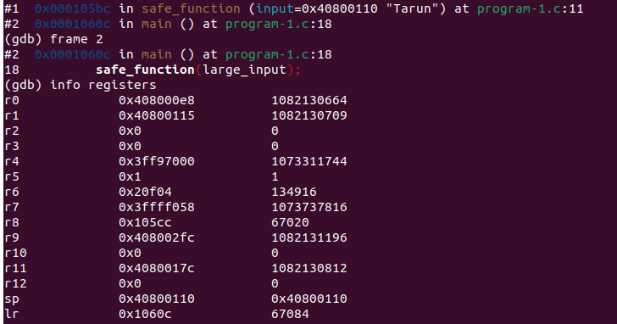
CS23B2004 TARUN MAMILLAPALLI

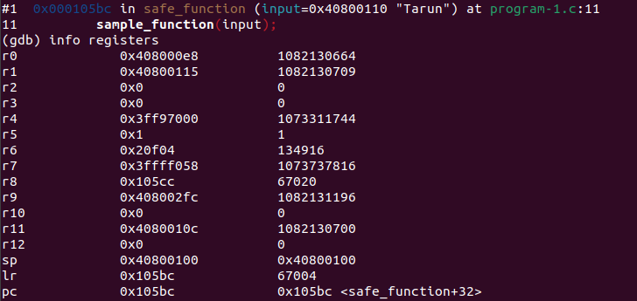
Q1) The above image displays the content of sp and lr of main function

Q2) The above image displays the content of sp and lr of safe_function

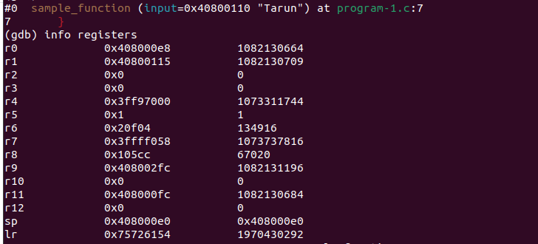
Q1) The above image displays the lr and sp values of the sample_function.

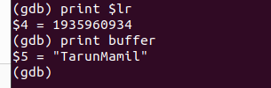

Q2) The original string has been cut.
The error is that the buffer array is only of size 10 but the string is of size 100. So, that is the problem.
Q3) To display the string at a memory location
x/s <address from which the string starts>

Q4)

#include <stdio.h>
#include <string.h>

void sample_function(char *input) {
char buffer[10];//HERE IT SHOULD BE BUFFER[100]
strcpy(buffer, input);
}

void safe_function(char *input) {
printf("In safe_function\n");
sample_function(input);
}

int main() {
char large_input[100];
printf("Enter the string\n");
scanf("%s", large_input);
safe_function(large_input);
printf("Main function complete.\n");
return 0;
}

